**Conservation Career Training Summer High School Internship**

*This project was funded by a grant from the Glenn W. Bailey Foundation*

**Scope of Internship:** The Barrier Island Center seeks two motivated high school students with multi-disciplinary interests to explore careers in environmental education and nature conservation through assisting staff in teaching a Sea Turtle TECH (Technology Education Challenges Horizons) STEM (Science, Technology, Engineering, Math) Mentorship Program for under-served youth, conducting ecological research/trail maintenance, maintaining display aquaria, assisting with gift shop financial reports and operations and receiving mentorship from environmental education and conservation professionals. Interns must be able to work professionally, independently and exhibit a positive attitude at all times, and mentor younger students.

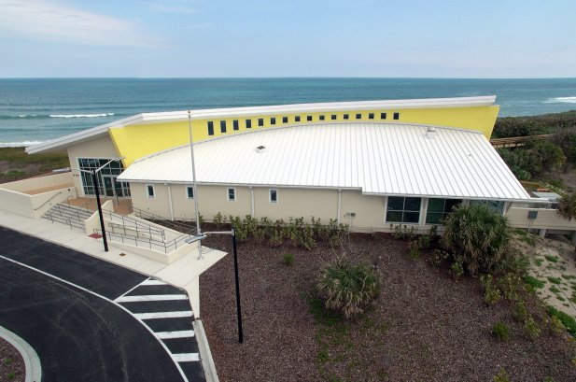**About the BIC, STC, EELS:** The Barrier Island Sanctuary Management and Education Center (Barrier Island Center) is an educational center located in the heart of the Archie Carr National Wildlife Refuge, a major nesting site for sea turtles in Melbourne Beach, Florida. Through a partnership with the Brevard County Environmentally Endangered Lands Program (EEL), the Sea Turtle Conservancy (STC) manages and conducts summer educational programs offered at the Barrier Island Center.

In North America, sea turtles primarily nest from North Carolina through Florida, with over 90% occurring in Florida. Within that range is the Carr Refuge, a 20.5-mile section of shoreline between Melbourne Beach and Wabasso, along Florida’s east central coast. Since its establishment by Congress in 1989, the Carr Refuge, named after STC’s founding scientific director, has been a major success. The stretch of beach within the Refuge boundary is home to the most important sea turtle nesting habitat in the United States. More loggerheads nest within the Carr Refuge than anywhere else in the Western Hemisphere. In addition, over the past several years there has been a significant increase in green turtle nesting. Protection of these beaches is essential to the survival and recovery of these species.

The Barrier Island Sanctuary also has beautiful hiking trails through coastal dunes, maritime hammock and mangrove swamp ecosystems and access to the biodiverse Indian River Lagoon, an estuary of national significance. The Barrier Island Center is a focal point for the Carr Refuge and the associated barrier island by providing exhibit space, a presentation hall and ongoing educational programs that promote stewardship of the area’s fragile natural resources. The Barrier Island Center hosts visiting school groups from throughout Brevard County, as well as local residents and tourists. The facility, gift shop and exhibits are open to the public. In its 17th year, the BIC serves on- and off-site over 30,000 children and adults through school excursion, camp, lectures, adult education, festivals, and numerous partnerships.

**Eligibility:** This internship is open to high school students of at least 16 years of age by June 1, 2025, preference will be given for those who qualify for free and reduced lunch, are eligible for work in the United States and able to lift 50 lbs. Students must have their own transportation and local housing.

**Commitment: Thursday, May 29th through Thursday, July 31st, 2025. Week one is a training week and is mandatory. Thursday, May 29th at 8 pm is mandatory turtle scout training. Paid internship begins Monday, June 2nd through Thursday, July 31st. Work schedule varies depending on the program needs, but adds up to a total of 20 hours per week and generally consists of three days, Tuesday, Wednesday and Thursday. Some night and weekend work will be required. July 26th and 27th are mandatory to assist with our Tour de Turtles release events.**

**Compensation:** This is a paid internship for $13.00 per hour.

**Application Deadline: April 1st, 2025.**

**Conservation Career Training Summer High School Internship**   
2025 APPLICATION

**Application Procedure: Complete the application form and email it along with supporting documentation (see application components below) to Sarah Rhodes-Ondi, Sea Turtle Conservancy, Community Stewardship Coordinator**, [sarah@conserveturtles.org](mailto:sarah@conserveturtles.org).

**Application Components:**

1. Completed Application Form.
2. One page essay describing career interests.
3. Two letters of reference from teachers or coaches (no relatives please). Email letters are accepted.

Name: ______________________________________________________________________________________

*Last First Middle*

Address: ____________________________________________________________________________________

*Number Street City State Zip*

Telephone: _____________________________ Date of Birth: ___________________________________

*Area Code and Number*

Email: ______________________________________________________________________________________

Mailing Address:

___________________________________________________________________________________________

*Number Street City State Zip*

Have you ever been employed by BIC? 🞏 Yes 🞏 No If yes, date: ________________________

High School Name and Location: _________________________________________________________________

High School years completed at start of internship: 1 2 3 4

Anticipated Graduation Date: ___________________

1. What is your interest in nature and the environment and sea turtles?
2. What do you hope to learn through the internship program at the Barrier Island Center?
3. Please describe any experience you have working with and mentoring younger children.
4. Please list any extracurricular (including sports, clubs, or organizations in which you are, or have been, involved), volunteer, leadership, or community activities you participate in or have participated in:
5. Please describe any special skills, interests, or hobbies you have:
6. Please list any special awards or honors you have earned:
7. Is there anything additional you would like to share?
8. How did you hear about this opportunity?
9. **Essay:** In one page (attached), please share your career interests and goals. Please describe how your internship at the Barrier Island Center will help your career path.

**Eligibility Requirements:**

1. Are you legally eligible for employment in the US? 🞏 Yes 🞏 No
2. Are you 16 by June 1, 2025? 🞏 Yes 🞏 No
3. Can you provide your own transportation? 🞏 Yes 🞏 No
4. Do you receive a free or reduced-cost lunch?* 🞏 Yes 🞏 No

*or*

Does your parent or guardian qualify for Assistance Programs (e.g. SNAP or TANF)?* 🞏 Yes 🞏 No

* **Please accompany this form with proof of one of the following:**

***(****Please check which)*

🞏 Enrollment in the Free and Reduced Lunch Program of your school

🞏 Enrollment in the Food Assistance Program (SNAP)

🞏 Enrollment in the Temporary Cash Assistance for Needy Families (TANF) Program

*More information on current gross household income meeting federal guidelines for free or reduce price meals can be found at:* [*https://www.isbe.net/Documents/HEA-68-06.pdf*](https://www.isbe.net/Documents/HEA-68-06.pdf)

By my signature below I certify that all information in this application is accurate to the best of my knowledge. I authorize the Barrier Island Center to seek verification as needed during the selection process.

_______________________________ _________________________

Signature Date